**IDENTIFICATION OF FUNCTIONAL REQUIREMENTS**

**1-A) ONLINE VOTING SYSTEM**

**Online Voting is simple, attractive and easy to use. It reduces manual efforts and bulk of information can be handled easily. System should provide concrete security features like creating users and assigning privileges to users of the system. System should be capable of keeping track of all the detailed descriptions of the client and the whole details of services offered by the client organization. Document suitable problem description with functional requirements specification for Online Voting System.**

**What is Online Voting?**

Online voting, often known as electronic voting, allows voters to vote from any location as long as they have internet access.  
End-to-end encryption and anonymity are among the security measures offered by [online voting providers](https://www.g2.com/categories/voting-management).  
Using [a voting system provider](https://www.gevme.com/en/blog/simple-guide-to-choosing-virtual-event-software/) is preferable to the manual procedure. It simplifies the complex voting procedure and provides a positive experience for both voters and administrators. Voting is increasingly easier, more cost effective, and ensures high voter turnout thanks to technological advancements.

**Benefits of Online Voting**

Electronic and online voting have numerous advantages over traditional methods of voting. Here are some of the primary reasons why it is so effective and successful, aside from ease.

1. **Accessibility/Availability**  
   Voting online increases accessibility to a dispersed member base and has been shown to increase level of participation. The simplicity of not having to send a ballot or attend a meeting, combined with several channel possibilities, allows your members to participate and vote no matter where they are.
2. **Votes are safeguarded/Protected**  
   Judgify Voting’s streamlined platform and processes are evaluated to ensure that only members who have been accredited are permitted to vote. The electronic voting method also assures that the traditional voting procedure’s norms, constitution, and governing laws are implemented and enforced.  
   All of this is made possible by the Judgify voting platform, which is created with cutting-edge technology to meet all levels of online voting services. The user interface is straightforward and safe, with a one-click solution for casting your vote. All of this takes place in a real-time, secure, and confidential voting system.
3. **Audit trail**  
   Judgify voting system for ballot and election audit processes is capable of passing the most demanding probity criteria. It is also adaptable to the needs of businesses in various industries. Everything from setting up the voting procedure to casting the vote is recorded and can be utilized to fulfil any audit requirements.
4. **Eases vote management**  
   The Judgify Voting system simplifies the time-consuming voting procedure and provides a pleasant experience for both voters and administrators. Voting members can simply cast their ballots by clicking on the link to their allotted online voting site. Judgify Voting will create and distribute unique logins for each voter.  
   The administration interface is simple to use for administrators, making it straightforward to set up and operate events, especially virtual or hybrid meetings like AGMs.
5. **Saves you time and Money**  
   Paper ballots, shipping, and printing are all required for traditional paper voting. Furthermore, calculating votes by show of hands necessitates additional staff. Conducting electronic voting considerably reduces implementation costs and improves election management efficiency. It provides precise, accurate, and rapid results.

Do you require assistance in running your next ballot, elections, enterprise agreements, or resolution voting? [To get started](https://www.judgify.me/l/), send us an email.

**Types of Voting Channels Online**

[Online voting](https://www.judgify.me/l/blog/harness-your-audience-with-a-leading-online-contest-voting-platform/)

is used to make any political process and business agreements more efficient and manageable. However, for some companies functioning in rural places with no internet connectivity, implementing electronic voting can be difficult. Choosing different voting methods allows your stakeholders and members more opportunities to vote regardless of where they are assigned or currently located.

**Here are the multi-channel voting systems for your members:**

1. **Online voting**  
   Electronic voting is the principal voting channel and a suitable solution for virtual ballot boxes. You can utilize this form of voting as long as you have an internet connection. The vote question appears once you have gained access to the voting panel via your mobile or tablet device. The vote button works properly on any device (laptop, desktop, or mobile) and can be accessed from anywhere.
2. **SMS voting**  
   If the internet is unavailable, voting through SMS is an excellent alternative if your members live in rural places. Sending a text message is what short message service is all about. SMS voting is exceptionally safe, simple, and rapid.  
   Using the mobile device’s security and biometrics functions, an SMS is delivered to the voters’ mobile number, to which they simply respond with a Yes or No. Voters can participate in the election as long as they can receive a text message.  
   SMS voting is ideal for a distributed workforce. This has been known to work on oil rigs or in regions where there is no internet access. Judgify can assist you in conducting your vote over SMS on the mobile phones of your employees. The vote can be cast from any location with mobile coverage at any time during the election.
3. **Phone voting**  
   Phone voting is a viable option for people of all ages and demographics. It enables groups to vote without the requirement for postal ballots or an internet connection. The accessibility and convenience of use encourages eligible voters to vote in a secure and reliable manner.

Mobile or telephone voting works by the voter dialing a phone number and listening to audio prompts, such as “Press 1 for Yes, 2 for No.” It then asks the voter the proper voting question when they enter their unique login and pin. This is quite simple and ideal for senior staff or those who are not computer adept. You will be able to vote as long as you have a phone connection, whether mobile or landline.

**NO MATTER THE TYPE OF VOTE YOU ARE PLANNING, OUR FLEXIBLE JUDGIFY ONLINE VOTING PLATFORM CAN SURELY SUPPORT YOUR NEEDS**

Organize an online vote among your association or company’s members; elect your board of directors; organize a public consultation; arrange a targeted referendum; establish polls and contests; and collect votes and input on multiple significant subjects and themes of interest at the same time. [Send us a request](https://www.judgify.me/l/contact-us/) for whatever project you have in mind, and one of our staff members will contact you to discuss your specific needs.

**1-B) LIBRARY MANAGEMENT SYSTEM**

Library Management System gives us the complete information about the library and the daily transactions done in a Library. We need to maintain the record of books and retrieve the details of books available in the library which mainly focuses on basic operations in a library like adding new member, new books, and up new information, searching books and members and facility to borrow and return books. It features a familiar and well thought-out, an attractive user interface, combined with strong searching, insertion and reporting capabilities. The report generation facility of library system helps to get a good idea of which are borrowed by the members, makes users possible to generate hard copy. Document suitable problem description with functional requirements specification for Library Management System  
  
The case study titled Library Management System is library management software for the purpose of monitoring and controlling the transactions in a library. This case study on the library management system gives us the complete information about the library and the daily transactions done in a Library. We need to maintain the record of new s and retrieve the details of books available in the library which mainly focuses on basic operations in a library like adding new member, new books, and up new information, searching books and members and facility to borrow and return books. It features a familiar and well thought-out, an attractive user interface, combined with strong searching, insertion and reporting capabilities. The report generation facility of library system helps to get a good idea of which are ths borrowed by the members, makes users possible to generate hard copy.  
  
The following are the brief description on the functions achieved through this case study:  
  
**End-Users:**  
•Librarian: To maintain and update the records and also to cater the needs of the users.  
•Reader: Need books to read and also places various requests to the librarian.  
•Vendor: To provide and meet the requirement of the prescribed books.  
  
**Class Diagram**  
Classes identified:  
Library  
Librarian  
Books Database  
User  
Vendor  
  
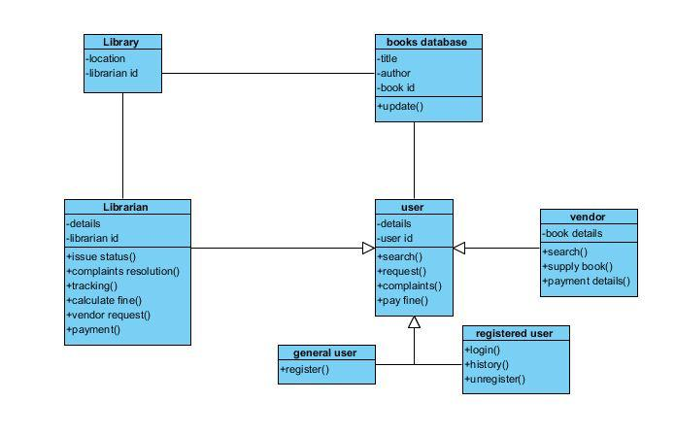  
 **Use-case Diagram**  
Actors vs Use Cases:  
Librarian  
•Issue a book  
•Update and maintain records  
•Request the vendor for a book  
•Track complaints  
  
User  
•Register  
•Login  
•Search a book  
•Request for isse  
•View history  
•Request to the Librarian  
•Unregister  
  
Books Database  
•Update records  
•Show books status  
  
Vendors  
•Provide books to the library  
•Payment acknowledgement  
  
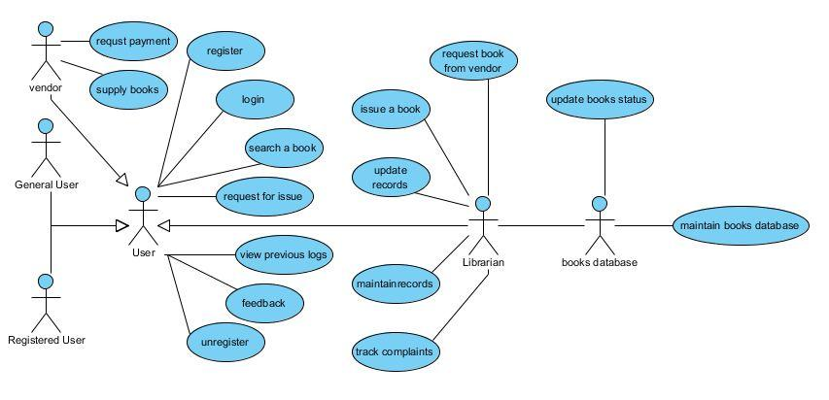

Sequence Diagram  
  
Sequence diagram for searching a book and issuing it as per the request by the user from the librarian:  
  
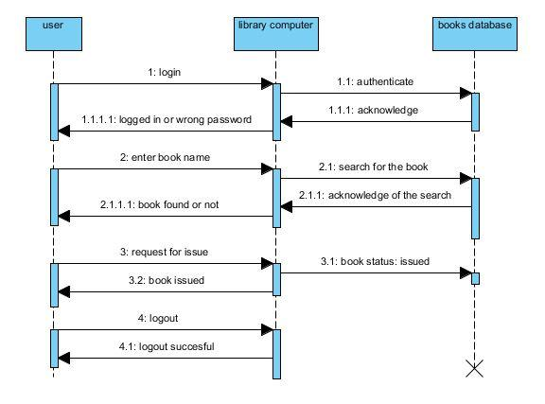  
  
Collaboration Diagram  
  
Collaboration Diagram for searching a book and issuing it as per the request by the user from the librarian:  
  
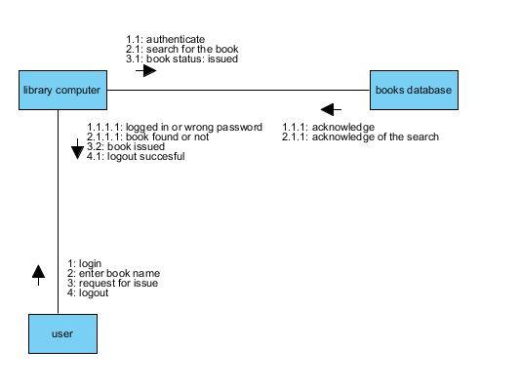  
Activity Diagram  
Activities:  
User Login and Authentication  
Search book operation for Reader  
Acknowledge and Issue books to the users by the Librarian  
Provide books requested by the Librarian from the Vendor  
Bill payment from the Librarian to the Vendor  
Status of the books updated in the Books Database  
  
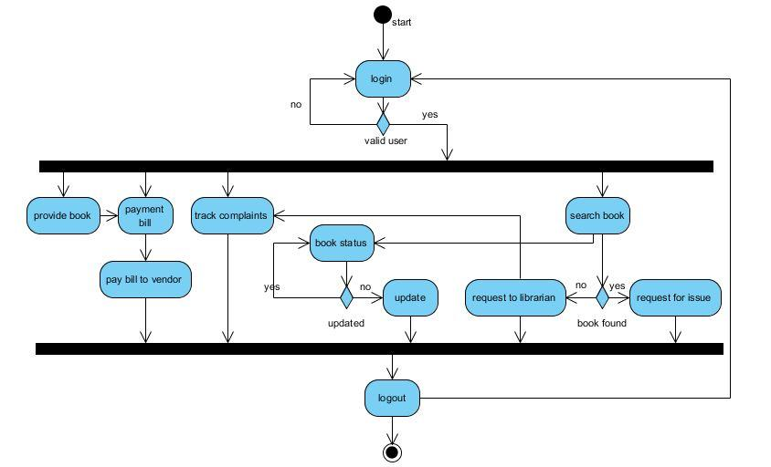

State Chart Diagram  
States:  
Authentication  
Successfully logged on or re-login  
Search for a book (user) / request the vendor (librarian) / provide the requested book (vendor)  
Receive acknowledgement  
Logged off / re-search / new function  
  
Transitions:  
Authenticate ---> Logged in  
Logged in ---> Search <---> Acknowledgement  
Logged in ---> Request Vendor <---> Provide Book <---> Acknowledgement  
Logged in ---> Provide Book <---> Acknowledgement  
Acknowledgement ---> Logged off  
  
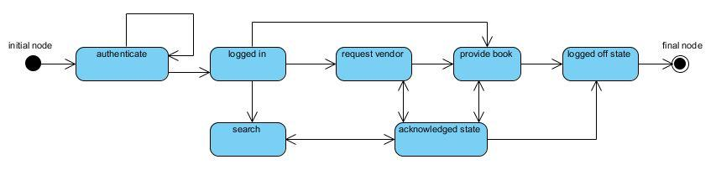  
  
Component Diagram  
Components:  
Register Page (visitor / vendor)  
Login Page (user / librarian / vendor)  
Search Page (user / librarian / vendor)  
Request Vendor Page (librarian)  
Request Book Issue Page (user / vendor)  
Issue Status Page (librarian)  
Make Payment Page (librarian / vendor)  
Provide Books Page (librarian)  
Logout Page (user / librarian / vendor)  
  
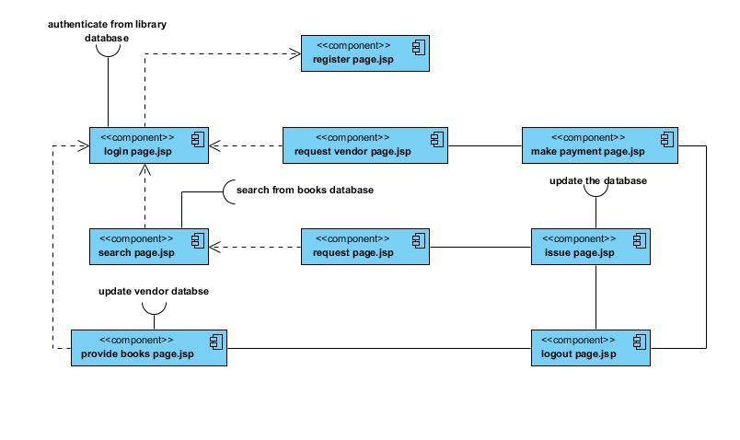  
Deployment Diagram  
  
Systems Used:  
Local Consoles / Computers for login and search purposes by users, librarian and vendors.  
Library LAN Server interconnecting all the systems to the Database.  
Internet to provide access to Venodors to supply the requested books by the Librarian  
Vendor Server to maintain the records of the requests made by the librarian and books provided to the library.  
  
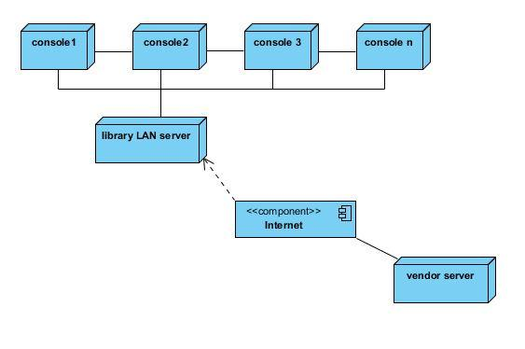

**1-C) ONLINE SHOPPING SYSTEM**

**Online Shopping system aims to develop an online shopping for customers with the goal so that it is very easy to shop your loved things from an extensive number of online shopping sites available on the web. With the help of this we can carry out an online shopping from our home. Here is no compelling reason to go to the crowed stores or shopping centers during festival seasons. Upon successful login the customers can purchase a wide range of things such as mobiles, books, apparel, jewellery, infant care, gifts, tools, etc. can be dispatched using online shopping system. Document suitable problem description with functional requirements specification for Online Shopping system.**

The process of buying products and services through the channel of the internet is called online shopping. It has great advantages over real markets. Many online stores are giving their best services to the people. The system of online shopping has increased it so vast. By sitting at any corner of the world you can avail the services. Due to the online shopping system, you can shop for any product from any place and get the delivery at your home. This online system has made it possible to approach any world’s market easily. You can go [**online einkaufen österreich**](https://almanda.at/)or other countries easily via the internet. Behind the online shopping system there are many objectives that you should know:

The following points show how online shopping takes place:

1)Connect to the internet and open online shopping website

2)Browse the website and choose purchase items

3)Add the item in the shopping cart

4)Continue shopping

5)Checkout and submit orders

6)Login or register on the website

7)Choose transport mode and delivery speed

8)Choose payment mode

9)Enter personal details like shipping address, phone number, email etc

10)Confirm order(s) and complete the payment

11)Shopping success and logout



1. **Manage the shopping details**: The whole system of online shopping manage the detail of each shopping done by the customers. They extract the product details of what consumers shopped.
2. **Manage the payment details:** In online shopping, customers get many options for mode of payments. Websites give them the option of online payment through debit or credit cards. Customers have also the option of net banking or cash on delivery payment option.
3. **Generate the information of customers and products**: Online shopping system manages the whole information about the customers and the purchased products.
4. **Reduce the cost of management:** Online shopping or digital shopping help in reducing the management cost of products.

**Following is some of the key features of our system, which distinguishes it from others:**

* Display all the available categories for shopping on the home page.
* Display all the subcategories on the home page, that are associated with any particular item.
* Admin has the authority to add new particulars to the items list whenever needed.
* Permission to the administrator to remove items, anytime.
* Allows the admin to modify the price of each item, whenever required or felt like.
* Admin has the authority to update the description of each item.
* Permission to the admin to view information about each customer who checkouts the items list.

**Conclusion:**

Online shopping system is developed by using a proper channel. The objectives of online shopping are pre-defined on which the whole system work to achieve them by managing the details of all customers, payments, bills, products, shopping, and so on. This system helps in boosting efficient services.